**Configuration of ANT:**

* Ant is a Build and compile tool
* To run the program from command prompt, we use build.xml file

1. Download Ant.--> <http://ant.apache.org/bindownload.cgi>

* Zip file (1.9.9 .zip archive: [apache-ant-1.9.9-bin.zip](http://mirror.metrocast.net/apache/ant/binaries/apache-ant-1.9.9-bin.zip) )
* Unzip the file

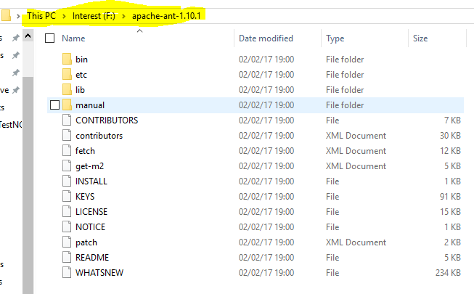

**2.**Set the Environmental variable ANT_HOME

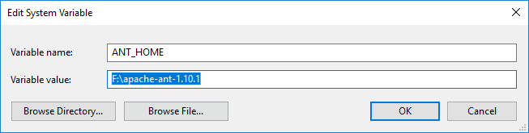

Add to the path Ant bin folder();

; F:\apache-ant-1.10.1\bin

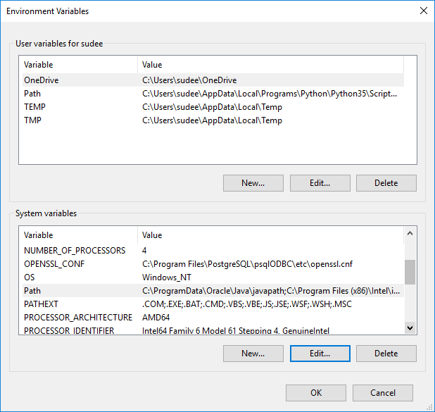

1. Enter in commant promt ant

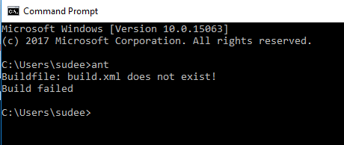

To execute we using ant we use Build.xml file

Build.xml is heart of ant

<?xml version="1.0" encoding="iso-8859-1"?>

<!DOCTYPE project [

]>

<project name="Learning TestNG" default="usage" basedir=".">

<!-- ========== Initialize Properties =================================== -->

<property environment="env"/>

<property name="ws.home" value="${basedir}"/>//the directory where build.xml is lying

<property name="ws.jars" value="F:\jars"/>//where all the jar files are lying,we are telling to ant{we need to change the path of jar file}

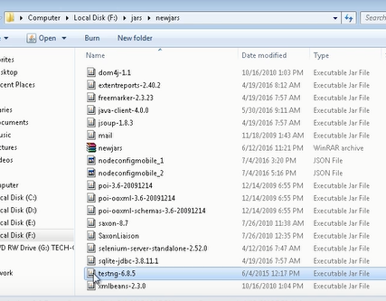

<property name="test.dest" value="${ws.home}/build"/>//

<property name="test.src" value="${ws.home}/src"/>// it tells where all the tests are lying

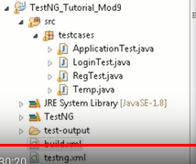

<property name="ng.result" value="test-output"/>//test output folder which is gererated after testng run

<!--target name="start-selenium-server">

<java jar="${ws.home}/lib/selenium-server.jar"/>

</target-->

<target name="setClassPath" unless="test.classpath">

<path id="classpath_jars">

<fileset dir="${ws.jars}" includes="*.jar"/>

</path>

<pathconvert pathsep=":"

property="test.classpath"

refid="classpath_jars"/>

</target>

<target name="init" depends="setClassPath">

<tstamp>

<format property="start.time" pattern="MM/dd/yyyy hh:mm aa" />

</tstamp>

<condition property="ANT"

value="${env.ANT_HOME}/bin/ant.bat"

else="${env.ANT_HOME}/bin/ant">

<os family="windows" />

</condition>

<taskdef name="testng" classpath="${test.classpath}"

classname="org.testng.TestNGAntTask" />

</target>

Here ,we have targets :

<!-- all -->

<target name="all">

</target>

<!-- clean -->

<target name="clean">

<delete dir="${test.dest}"/>

</target>



It will set configuration based on below targets

Go to the path of project->properties

Ant compile🡪cmd(make sure project jar file are included in jars else build will get fail)



project --

>After that refresh will see in project 🡪test out put folder

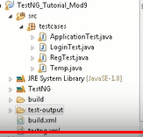

>After that refresh will see in project 🡪Build folder will be created automatically

//target compile will convert jave files into class files .

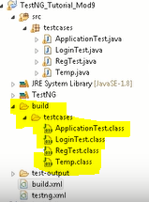

<!-- compile -->// compile project based on this target

<target name="compile" depends="init, clean" >

<delete includeemptydirs="true" quiet="true">//delete the dir build

<fileset dir="${test.dest}" includes="**/*"/>

</delete>

<echo message="making directory..."/>

<mkdir dir="${test.dest}"/>

<echo message="classpath------: ${test.classpath}"/>

<echo message="compiling..."/>

<javac //compile and execute the jave files

debug="true"

destdir="${test.dest}"

srcdir="${test.src}"

target="1.5"

classpath="${test.classpath}"

>

</javac>

</target>

<!-- build -->

<target name="build" depends="init">

</target>

<!-- run -->//it runs as per testng.xml

<target name="run" depends="compile">

<testng classpath="${test.classpath}:${test.dest}" suitename="suite1">

<xmlfileset dir="${ws.home}" includes="testng.xml"/>//path where the testng.xml file is lying



-----------------------------------------------------------------------------------

Eg:simple example how we need to set the testng.xml location



Taget <run >

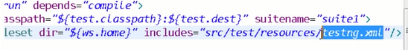

------------------------------------------------------------------------------------------------------------------

<!--

<testng classpath="${test.classpath}:${test.dest}" groups="fast">

<classfileset dir="${test.dest}" includes="example1/*.class"/>

</testng>

-->

</target>

<target name="usage">

<echo>

ant run will execute the test

</echo>

</target>

<path id="test.c">

<fileset dir="${ws.jars}" includes="*.jar"/>

</path>

1.//tesng-results.xsl🡪 get this file for better reports

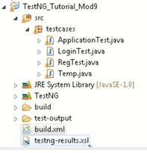

Add this 2 jars to jars folder



<target name="makexsltreports">

<mkdir dir="${ws.home}/XSLT_Reports/output"/>

<xslt in="${ng.result}/testng-results.xml" style=" testng-results.xsl"

out="${ws.home}/XSLT_Reports/output/index.html" classpathref="test.c" processor="SaxonLiaison">

<param name="testNgXslt.outputDir" expression="${ws.home}/XSLT_Reports/output/"/>

<param name="testNgXslt.showRuntimeTotals" expression="true"/>

</xslt>

</target>

<!-- ****************** targets not used ****************** -->

</project>

